**Design of the Experiment**

**Between-subjects design:**

**Design**: 2 (*TARGET-SOURCE color matching:* TARGET1[TARGET2] matching positive[negative]Sources vs. TARGET2[TARGET1] matching positive[negative]Sources) between-subject design. Method factors varied between participants:

* + - *Stimulus assignment*: TARGET1/TARGET2 identity assigned to same color as positive/negative words
    - *Order of evaluative measures*: IAT before vs. after self-reports
    - *IAT block order* (consistent vs. inconsistent with learning phase).

**Stimuli.** Two nonsense words (MORAG and STRUAN) will serve as TARGET1 and TARGET2. Six positive (*Love, Happy, Beautiful, Peace, Friendship, Success*), six negative adjectives (*Agony, Murder, Vomit, Disease, Cancer, Torture*), and six neutral nouns (*Table, Building, Glass, Street, Number, Bowl*) will serve as Sources.

**Participants.** Data-collection will be via the Prolific website (prolific.achttps://prolific.ac/). We will stop data-collection as soon as 250 participants have completed the experiment on the Prolific website. Recruiting 171 participants will allow us to have good power (> 0.90) to observe a medium EC effect (*f* = 0.25) driven by SOURCE-TARGET color matching, at alpha = 0.05. We decided to collect additional participants in order ensure that the necessary sample size was still obtained after exclusions.

**Procedure.**  EC 🡪 Evaluative measures 🡪 Exploratory Questions

*EC training phase*. Participants receive three blocks of 16 trials (48 total) consisting of two different types of trials: one type of trial wherein TARGET1 is eventually presented in the same color as a positive source, and another trial in which TARGET2 is eventually presented in the same color as a negative source. Note that each trial will contain eight stimuli simultaneously presented onscreen: two neutral targets (MORAG or STRUAN), two positive sources, two negatively sources, and two neutral sources. All eight stimuli will initially be presented in the same color (white). Then after 3000ms, depending on the TARGET present on that trial, one TARGET and SOURCE will turn change to a different color (e.g., purple), while the remaining stimuli will maintain the same color (white). The stimuli will remain onscreen for another 3000ms before all stimuli are removed, an inter-trial interval of 1000ms, and the next trial. Stimulus color will be varied across each trial, so that none of the colors can assume any specific positive or negative value. Four different colors (i.e., lime, fuchsia, yellow, and deepskyblue) will be used.

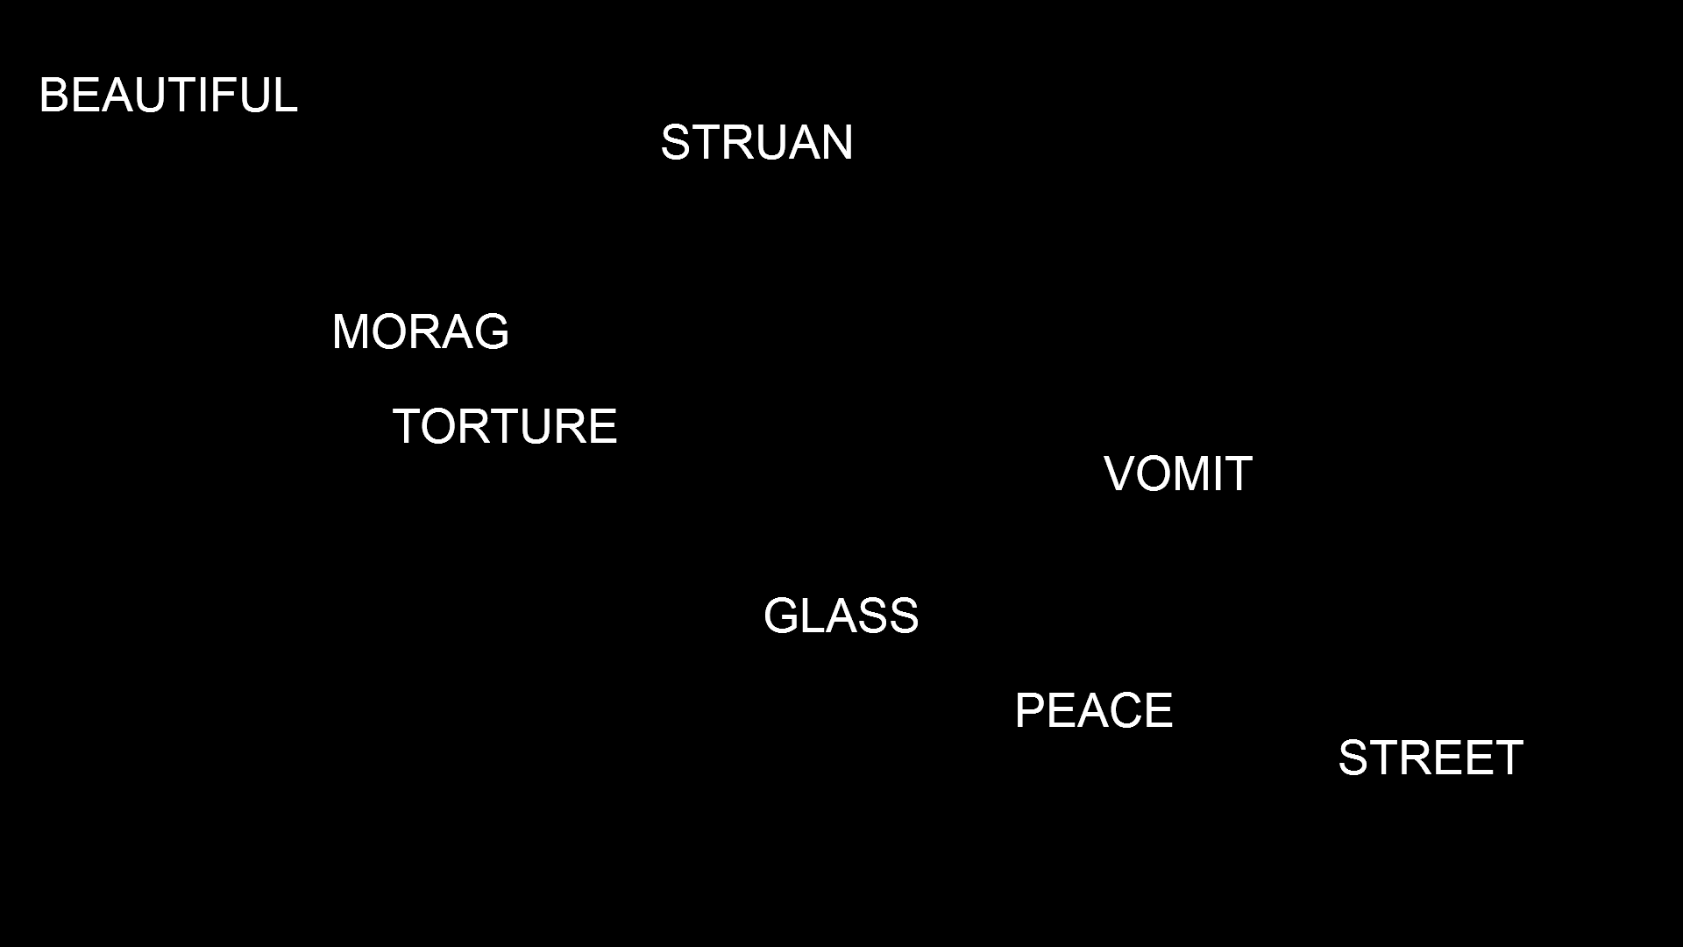

**PEACE**

**MORAG**

Figure 1. Example of a trial during the learning phase.

*Implicit attitude*

Participants will perform an IAT measuring implicit evaluations of TARGET1 vs. TARGET2:   
The IATs involve categories “TARGET1” and “TARGET2” and “Good” and “Bad”  
  
IAT Procedure:

a. Instructions: “In the next part you will have to categorize items into groups as fast as you can.”

b. 20 practice trials sorting TARGET1 on the left and TARGET2 on the right.   
  
c. 20 practice trials sorting positive words on the left and negative words on the right.

d. 20 test trials TARGET1 and positive words Sourceing one key and TARGET2 and negative words Sourceing another key.

e. 40 test trials TARGET1 and positive words Sourceing one key and TARGET2 and negative words Sourceing another key.

f. 20 practice trials TARGET2 on the left and TARGET1 on the right.

g. 20 test trials TARGET2 and positive on the left and TARGET1 and negative on the right.

h. 40 test trials TARGET2 and positive on the left and TARGET1 and negative on the right.

NOTE: IAT stimuli are:

* + - TARGET1
    - TARGET2
    - Positive words: *Fantastic, Great, Nice, Good, Pleasant, Wonderful, Amazing, Happy*
    - Negative words: *Terrible, Disgusting, Nasty, Horrible, Sick, Awful, Sad, Unpleasant*

*Explicit attitude*. Participants give explicit ratings of the two TARGETs by answering the question:

*“Please rate the above item using the scale below*  
options: -5 =Negative, 5= Neutral, +5= Positive

options: -5 =I Dislike it, 5= Neutral, +5= I Like it

options: -5 =Bad, 5= Neutral, +5= Good

options: -5 =Unpleasant, 5= Neutral, +5= Pleasant

*Intention measure*. Participants are presented with two brand products labeled with either TARGET1 or TARGET2. They are asked to indicate which of these products they would try and given the following options: “I would try TARGET1, I would try TARGET2, I would try neither”.

Finally, participants answer the following exploratory questions about the EC task:  
  
 *Contiguity memory*: "In the beginning of the experiment (see below) we initially presented MORAG/STRUAN together with several words. MORAG/STRUAN and these words all appeared in WHITE. Did the OTHER words...?"

("always have a positive meaning", "always have a negative meaning", "have different meanings (e.g., some were positive, some were negative, some were neutral)", "I don’t remember")

C*olor memory 1*. “"During the first part of the experiment (see below) MORAG/STRUAN and another word changed color. Did MORAG/STRUAN...:"

and POSITIVE WORDS subsequently share a color", "and NEGATIVE WORDS subsequently share a color", "and NEUTRAL WORDS subsequently share a color", "I don’t remember")

*Manipulation check*. “Did you ever take notes (or write down) what happened in order to help you figure out what was going on? Please be honest here (you will receive payment regardless of what you say).”

*Demand Compliance (explicit):* "Earlier you rated MORAG and STRUAN as being either positive, neutral, or negative. Did you base your response on how you actually felt about those words OR on what you thought the researchers wanted you to say?"

How I actually felt about MORAG and STRUAN", "What I thought the researchers wanted me to say (i.e., not on how I personally felt)", "I don’t know")

*Demand compliance (implicit).* Earlier you completed the Implicit Association Test (see below). Did you base your performance in that task on your best efforts to perform the categorizations as quickly and accurately as possible? Or did you attempt to influence your speed or accuracy in order to go along with what you thought the researchers wanted you to feel about the words?"

("I tried to perform the task as quickly and accuarely as possible", "I tried to alter my performance based on what I thought the researchers wanted to find", "I don’t know")

*Reactance. (Explicit).* Earlier you rated MORAG and STRUAN as being either positive, neutral, or negative. Did you consciously resist what you thought the researchers wanted you to feel about those words?"

("Yes", "No", "I don’t know")

*Reactance (implicit).* Earlier you completed the Implicit Association Test (see below). Did you try to influence your speed or accuracy in order to consciously resist what you thought the researchers wanted you to feel about those words"

("Yes", "No", "I don’t know")

*Hypothesis awareness*. Think back to the first part of the experiment. We showed you MORAG and POSITIVE WORDS in the same color. We also showed you STRUAN and NEGATIVE WORDS in the same color. Did you notice this during the first part of the study? Please be honest here"

*Influence awareness*. Do you think that the fact that MORAG and POSITIVE WORDS were presented in the same color (and that STRUAN and NEGATIVE WORDS were presented in the same color) influenced how much you like or dislike MORAG or STRUAN? Please be honest here"